LOANS REMOVED FROM FORECLOSURE PROCESS DUE TO DEED IN LIEU

In order to show that the account was removed from the FORECLOSURE IN PROCESS list or queue we need to show that the account was in the foreclosure process. What I mean is that it will have to show that the account had been sent to the attorneys for this delinquency(papers to the attorneys) The investors like FHA,VA and Fannie Mae state the present delinquency starts from the most recent due date of next payment. Based on the guides we really don’t need to start a Deed in Lieu once that account is in the foreclosure stage but the investor would rather had a Deed in Lieu . We should not have many accounts in this list coming out of the foreclosure process. I believe the accounts are put into this queue by populating the MS system under the foreclosure tracing tab. We would need to have the following
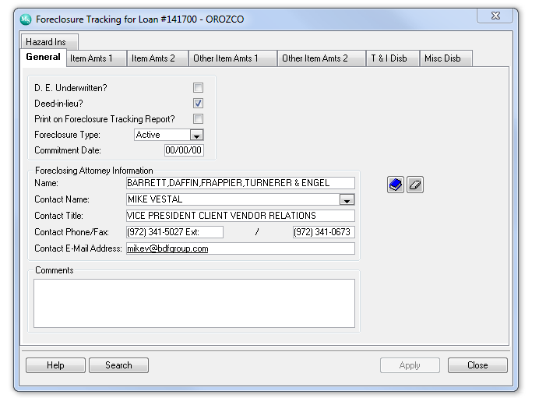

The way the Loans Removed from Foreclosure due to Deed in Lieu is now we show loans that have been in the Deed in Lieu stage from day one. In other words it’s picking up any loan I start a Deed in Lieu and I populate the MS system with the above info. We will eventually have a queue for Deed in Lieu all by itself but to show how it went from Foreclosure to Deed in Lieu it has to have a flow of events.

I’m thinking the conditions we gave you for a loan that is in foreclosure should be their previously to have an account move to the Deed in Lieu list. For example if the Foreclosure Tracking has Active and boxed for Print on Foreclosure Tracking Report checked and we received Deed in Lieu documents we need to uncheck that box and Check the box for Deed in Lieu. This will be the condition to move a file from foreclosure process list to Deed in Lieu List.

Can we remove demand letter sent and last payment received from the Deed in Lieu list?
Add due date of next payment.
Add UPB

FORECLOSURE REVIEW CHECKLIST

- WAS PROPERTY INSPECTION ORDER?
CONDITIONS: INFORMATION IS TAKEN FROM MEMO TYPE (PI-COMPLETED) AND WILL SEARCH FOR THIS INFORMATION FROM DEMAND EXPIRATION DATE MINUS 45 DAYS.
NOTES:
IF WE UPDATE THESE CONDITIONS TO PICK ANY INSPECTION ORDERDED BY THE ACTIUAL DATE IT WAS ORDERED. FOR EXAMPLE ONCE WE ORDER AN INSPECTION THE SYSTEM MEMOS IT TO MS LIKE THIS:

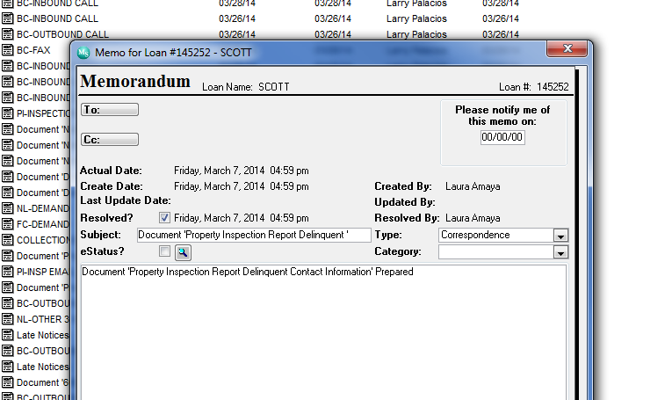

ALL WE NEED TO CHANGE IS THE TYPE (PI-ONGOING EXT/OCCUPANCY) OR (

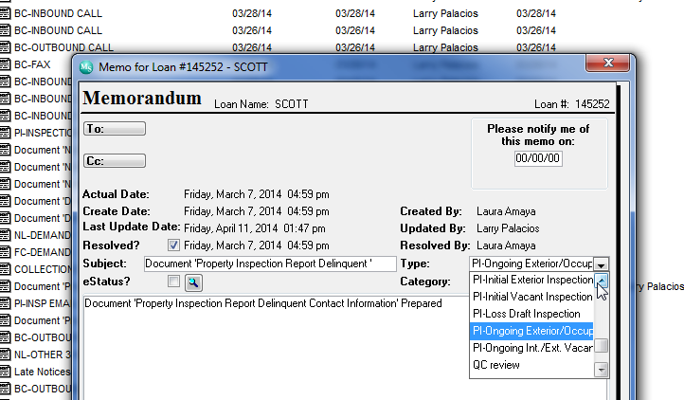

4. DID BORROWER DISCUSSED THAT HE OR SHE NEEDED HELP AND WAS GOING TO SUBMIT A FINANCIAL FORM?
CONDITIONS: INFORMATION IS TAKEN FROM MEMO TYPE (BC-FIRST RIGHT PARTY CONTACT) IT ALSO WRITES IN THE BODY OF THE MEMO. THIS INFORMATION IS ALSO TAKEN FROM DEMAND EXPIRATION DATE MINUS 455 DAYS.
NOTES:
HOW CAN WE PICK UP A YES OR A NO WITHOUT ASSUMING THAT IF THERE IS A MEMO TYPE JUST ADD THE YES? MAYBE JUST ADD THE DATE OF THE MEMO AND THE BODY OF THE MEMO AND HAVE REVIEWER DECIDE IF THERE WAS A YES OR A NO?

6. WAS THE PROPERTY VACANT OR ABANDONED AND WAS IT SECURED?
CONDITIONS: I’M NOT TOO SURE HOW THE CONDITIONS ARE PICKED FOR THIS QUESTION? OR I DO NOT REMEMBER.

